# SUPERIOR-GREENSTONE DISTRICT SCHOOL BOARD

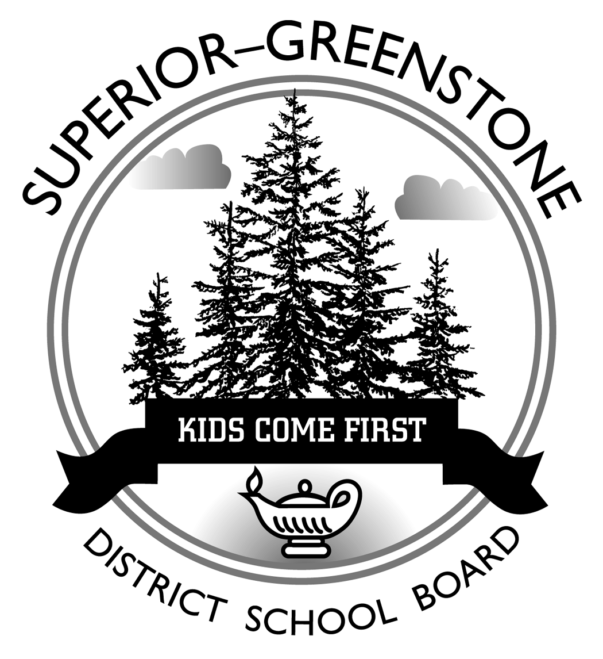

# *P.O. Bag ‘A’, 12 Hemlo Drive*

# *Marathon, Ontario P0T 2E0*

# *Telephone: 807-229-0436 Fax: 807-229-1471*

# *E-Mail: boardoffice@sgdsb.on.ca*

# PRESS RELEASE

FOR IMMEDIATE RELEASE

**Date:** Wednesday, May 26, 2010

**Contact:** Valerie Newton, Acting Director of Education / Julie Sparrow, Board Chair

Superior-Greenstone District School Board

Phone: 807-229-0436 Fax: 807-229-1471

E-Mail: [vnewton@sgdsb.on.ca](mailto:vnewton@sgdsb.on.ca) / [jsparrow@sgdsb.on.ca](mailto:jsparrow@sgdsb.on.ca)

***Superior-Greenstone DSB Hosts Hello Leadership-Student Workshop***

**MARATHON, Ontario** – Seventeen Superior-Greenstone District School Board (SGDSB) Grade 11 students and student trustees, Kayla Kjellman and Sarah Duffus participated in a day-long student leadership workshop held at the Nipigon Community Centre on April 28. Facilitated by David Lyle the founder of Hello Leadership out of Dryden, ON, the day’s focus was on building — teams, character and community. The hands-on, experiential learning format presented by Lyle, allowed students to explore from their perspective what they felt worked in schools and what improvements were needed in their high schools.

A very enthusiastic, Lyle lead the group of students and staff advisors through some fun, team building leadership activities. In small group discussions students talked about the strengths and weaknesses in their current, secondary schools; and about relationships between diverse groups of students, between students and staff, as well as student interaction with community members in secondary schools. The dialogue lead to a focused discussion and plan of action for each student group upon their return to their everyday school setting. They pondered ideas on how to strengthen schools with respect to programming, course offerings and student choices. As individual students in the school and as groups of like- minded students, they discussed the merits of being role models for other students by promoting a more inclusive and positive school environments was discussed at length. The students worked on plans to move forward in promoting a positive climate in the school and formulated ideas for their next steps in schools.

During the process, students found that on the whole, their schools were welcoming and caring school environments. The pros and cons of knowing everyone in a small high school which is the norm in all

-more-

Student Leadership Workshop

May 26, 2010

Page 2

SGDSB high schools were discussed. Students believe that core values and beliefs are factors that separate them more than race, ethnicity, religion and sexual orientation. However, they concur that, in some cases, a negative attitude does exist toward those students who are seen as ‘different’ than other students in their school. One thing was for certain, this group of students thought it was definitely cool to be ‘yourself’ and to not give into to negative peer pressure. School-wide and/or community based activities such as school jamborees, fun days and walk-a-thons were ideas that gained enthusiastic support. Students felt these kinds of activities could greatly accent positive mindsets and raise school spirit.

An area that students expressed a desire to be more involved was in the operations of the school, that is having the opportunity to offer input into how the school runs. Taking a more active part in this area would help students acquire knowledge of the operations and in turn students might better understand and support decisions taken by the school administration and the Board. Some students commented that they are asked for feedback on course materials and practices at the end of the semester, but would like to see this happen in all courses across all secondary schools.

Most students thought they were academically well prepared for their next step to — college, university or apprenticeship. However, they commented on the need for more student choice in courses of study. They cited choices in foreign languages such as Spanish, German, etc.; elective courses such as photography, digital media and more social science and humanities courses offered throughout secondary school careers would be most welcomed.

In a final exercise, each student was asked to reflect and write “a note to self” about one action that he/she would undertake in line with their vision of enhancing their schools. Within a month from now, the students will do a reality check on what they have achieved in regard to their action note.

The students agreed that the day was an inspirational event and it was exciting to meet and share experiences. As the day wrapped up, the students strongly recommended that similar opportunities be presented in the future for students to get together to share their ideas, opinions, experiences, problems and solutions. A giant thumbs up from the students and administrators alike goes out to David Lyle for facilitating a great workshop!

- 30