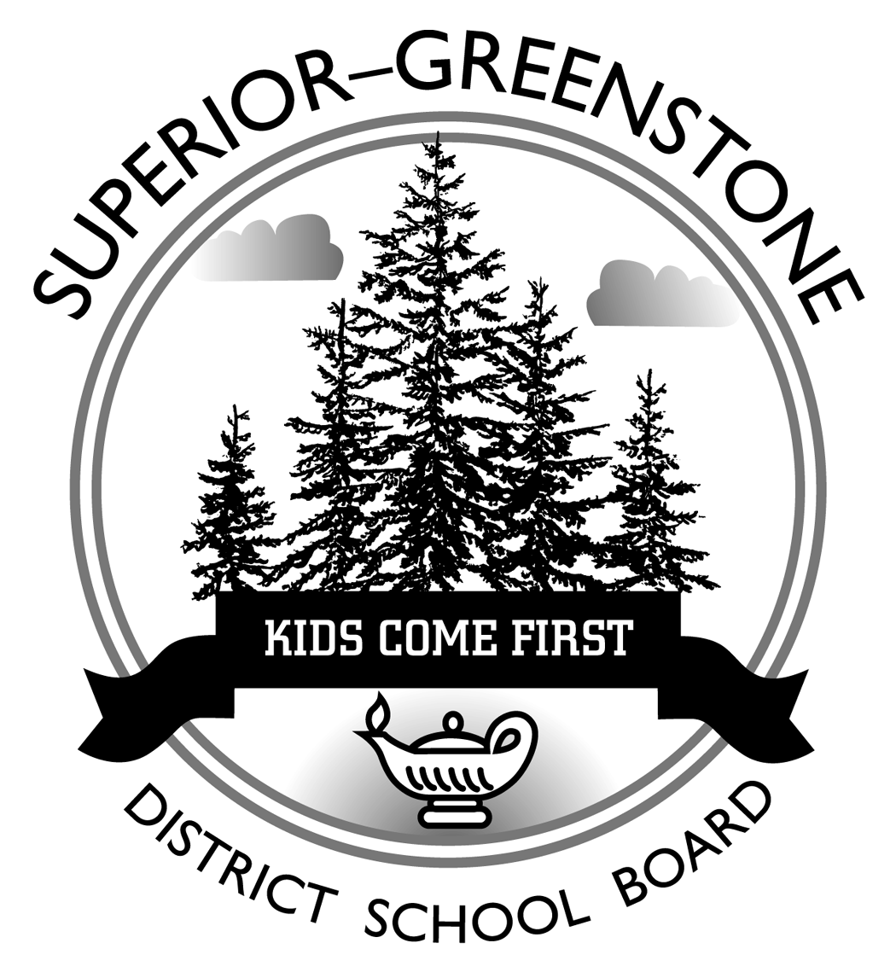
Superior-Greenstone District School Board

Pathways for Success

Student’s Name:
School: | Marathon High School

Grade: My goal is to achieve: Passed Grade 10 Literacy Test
Completed 40-hours of volunteer work

Post Secondary Destination: Program (Optional):
Occupational Goal: Prerequisites (Optional): English Other:

Group 1: Additional English, or  Third Language, or  Social Science and the Humanities,  or Canadian and World Studies, or  Co-operative Education |  |  |  |  | Group 2: Health and Physical Education,  or The Arts,  or Business Studies,  or Co-operative Education |  |  |  | Group 3: Science,  or Technological Education,  or Co-operative Education
Grade | English |  | Mathematics | Science |  | Canadian & World Studies/Social Sciences | Languages/  Guidance/  Career Studies | Health & Physical Education |  | Arts | Technology,  or Business Studies
9 |  |  |  |  |  |  |  |  |  |  | Group 3 or Elective
10 |  |  |  |  |  | Compulsory Credit Course .5  CHV2O Open | Compulsory Credit Course .5  GLC2O Open | Group 2 or Elective |  | Group 2 or Elective | Elective
11 | Co-op/OYAP | Co-op/OYAP |  | Group 3 or Elective  Co-op/OYAP |  | Group 1 Elective  Co-op/OYAP | Elective  Co-op/OYAP | Elective  Co-op/OYAP |  | Elective  Co-op/OYAP | Elective  Co-op/OYAP
12 | Group 1 or Elective  Co-op/OYAP | Elective  Co-op/OYAP |  | Co-op/OYAP |  | Elective  Co-op/OYAP | Elective  Co-op/OYAP | Elective  Co-op/OYAP |  | Optional Elective  Co-op/OYAP | Optional Elective  Co-op/OYAP

