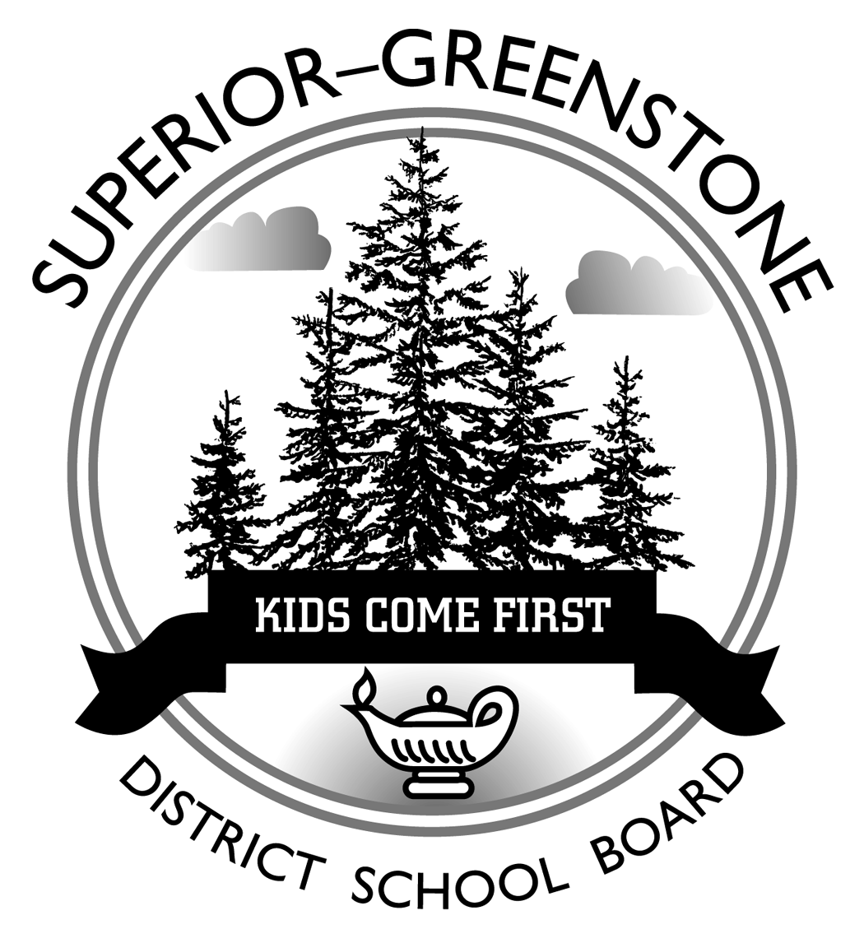
Superior-Greenstone District School Board

Pathways for Success

Student’s Name:
School: | Nipigon-Red Rock District High School

Grade: My goal is to achieve: Passed Grade 10 Literacy Test
Completed 40-hours of volunteer work

Post Secondary Destination: Program (Optional):
Occupational Goal: Prerequisites (Optional): English Other:

Group 1: Additional English, or  Third Language, or  Social Science and the Humanities,  or Canadian and World Studies |  |  |  |  | Group 2: Health and Physical Education,  or The Arts,  or Business Studies |  |  |  | Group 3: Science,  or Technological Education
Grade | English |  | Mathematics | Science |  | Canadian Geography  /History | French  /Ojibway | Physical Education |  | Arts | Technology,  or Business Studies
9 |  |  |  |  |  |  |  |  |  |  | Group 3 or Elective
10 |  |  |  |  |  |  | Compulsory Credit Course .5  GLC2O Open  CHV2O Open | Group 2 or Elective |  | Group 2 or Elective | Elective
11 |  |  |  | Group 3 or Elective |  | Group 1 Elective | Elective | Elective |  | Elective | Elective
12 |  | Elective |  | Elective |  | Elective | Elective | Elective |  | Optional Elective | Optional Elective

